Q1 | Create a table called Restaurants with columns: id, name, cuisine, rating, and city. Insert at least 5 sample records representing real or fictional restaurants you might find on Zomato.
Code | Create table:  CREATE TABLE Restaurants ( id INT AUTO_INCREMENT, name VARCHAR(50), cuisine VARCHAR(50), rating DECIMAL(2,1), city VARCHAR(50), PRIMARY KEY(id) );  Insert record:  INSERT INTO Restaurants VALUES (1, 'Swagat', 'North Indian', 4.5, 'Ahmedabad'), (2, 'Spice Villa', 'Chinese', 4.2, 'Surat'), (3, 'Swadisht', 'South Indian', 3.8, 'Vadodara'), (4, 'Pizza House', 'Italian', 4.7, 'Ahmedabad'), (5, 'Food Corner', 'Chinese', 3.6, 'Surat');
Output | 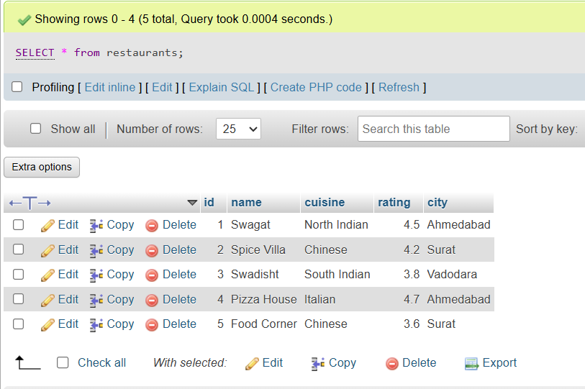

Q2 | Write a SQL query to find all restaurants in the Restaurants table that have a rating greater than 4.0 and are located in either 'Ahmedabad' or 'Surat'.
Code | SELECT * FROM Restaurants WHERE rating > 4.0 AND city IN ('Ahmedabad', 'Surat');
Output | 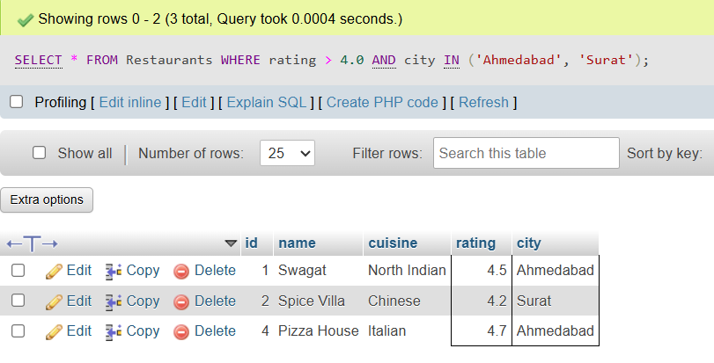

Q3 | Using the LIKE operator, write a query to select all restaurants whose names start with 'Swa' (for example, 'Swagat', 'Swadisht') from the Restaurants table.<br><br><em><strong>Hint:</strong> Use LIKE 'Swa%'.</em>
Code | SELECT * FROM Restaurants WHERE name LIKE 'Swa%';
Output | 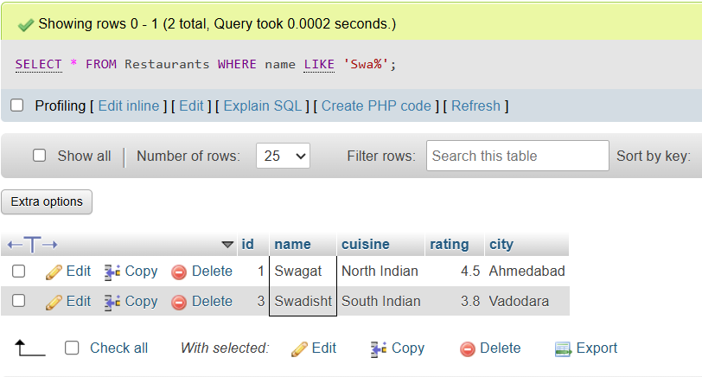

Q4 | Write a SQL query using the BETWEEN keyword to find all restaurants in the Restaurants table with a rating between 3.5 and 4.5 (inclusive).
Code | SELECT * FROM Restaurants WHERE rating BETWEEN 3.4 AND 4.5;
Output | 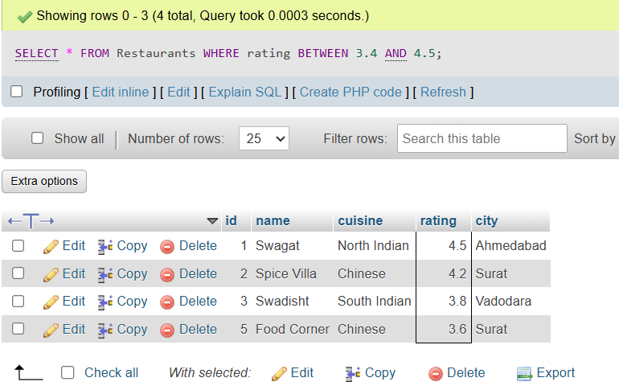

Q5 | Write a query to find all restaurants whose cuisine is either 'Chinese', 'Italian', or 'South Indian' using the IN operator.
Code | SELECT * FROM restaurants WHERE cuisine IN('Chinese', 'Italian', 'South Indian');
Output | 